Visvesvaraya National Institute of Technology, Nagpur
Department of Electronics & Communication Engineering
Signals n Systems (ECL 211)
Tutorial sheet -1
Q.1 Carry out following operations on the signal shown in fig.
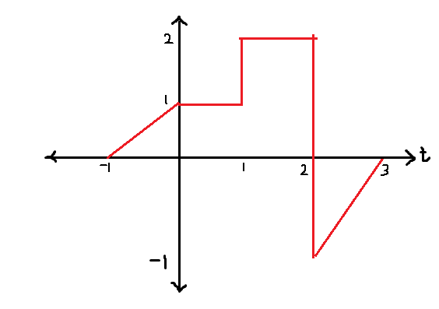
- x(t-2)
- x(1-t)
- [x(t) +x(1-t)] u(t-1)
- x(t) [ δ(t+3/2) - δ(t-3/2)]
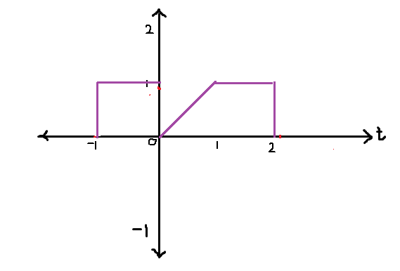
- plot x(1-t/2) for the above fig.
Q.2 Find whether following signals are periodic or not
- x(t) =2cost+3cos(t/3)
- x(t) =2 cosπt + 7 cost
- x(t) =2 cos 1.5 πt + sin 3.5πt
- x[n]=cos[2n]
- x[n]=cos[2πn]
- x[n]=cos[2πt]²
Q.3 Determine whether following signals are energy or power signals and calculate their energy or power.
- x(n) =(1/2)^{n} u(n)
- x(t) = rect (t / T₀)
- x(t) =cos² w₀t
- x(t) = rect (t / T₀) cos w₀t
- x(n) = u(n)
- vi) x(t) = A e^{-αt} u(t) ,α >0
Q.4 Find and sketch the even and odd components of the following.
- x(n) =e^{- (n /4 )} u(n)
- x(t) = {t 0≤t≤1
= {2-t 1≤t≤2
- x(t) =cos² (πt /2)
Q.5 Draw the waveform for the following.
- f₂(t) = -2u(t-2)
- f₂(t) = -(t-2)u(t-2)
Q.6 Determine whether signals are periodic or not , determine fundamental period if periodic.
- cos (n/8) cos (nπ/8)
- sin (π+0.2n)
- 2 cos100πt +5 sin 50t

